
‘Opening the Gate to Success’
Personal Development, Behaviour and Welfare Policy 2019-20

This policy is written in accordance with the agreed Governor’s Statement of Behaviour Principles which can be found on the School’s website.

The policy has been revised after successful use and after the School has earned a reputation among staff, parents, the Futures Trust and visitors to the school for good behaviour.
All staff are required to adhere to this policy, including temporary, volunteers or supply staff.

AIMS:

- This policy aims to be clear, concise and easily understood by all staff, pupils and parents.
- The policy fully supports the principles of ‘Restorative Approaches’
- Positive relationships are at the core of our values at Parkgate Primary.
- It is based on a mutual understanding that expectations for children’s behaviour and welfare at Parkgate Primary are very high.
- The system aims to be fair and equitable to all, regardless of age, gender, sexual orientation or ethnicity.
- The policy encourages a ‘fresh start’ approach and all children have a ‘clean slate’ at the start of each day/lesson.
- The reward and sanction systems enable children to achieve success at school through the choices that they make on a daily basis about their behaviour and how they regulate it.
- The system encourages both an individual and a collegiate approach to rewards for good behaviour.
- For children who have been identified with significant behavioural needs then additional support will be provided on an individual basis and that support would be detailed in an Individual Behaviour Plan (IBP)
- Incidents of poor behaviour will be recorded on a secure electronic system CPOMS which is reviewed and analysed on a regular basis.
- Successes will be celebrated during Celebration Assemblies on Mondays where parents may share in their child’s achievements
- This Personal Development, Behaviour and Welfare Policy fully supports our PSHCE policy and practice. Aspects of this policy will be addressed in the PSHE curriculum via the following themes:
- Rights and Responsibilities
- Restorative Approaches
- Protective Behaviours
- Mental Health and Well-Being (WAS Award)
- Identity (Inc. British Values)
- Healthy Lifestyles
- Positive Relationships
- Changes and Transitions

There are also regular opportunities for pupils to share their views within a cycle of consultation. There are nominated representatives from each class who form the School Council and the Eco Council. This process enables children, through healthy debate and dialogue, to understand democracy.

OUR RIGHTS

These rights have been devised and shared by the children and staff of Parkgate Primary School. They are clear, easy to understand and are all based on the principle of respect. The rights are displayed clearly in every classroom throughout the school.

At Parkgate we uphold the following rights:

The Right to learn (including the Right to teach)

The Right to be safe

The Right to be respected

LEARNING BEHAVIOURS
At Parkgate we encourage positive Learning Behaviours through the use of Learning Cogs which link together to drive Challenge, Resilience, Aspiration and Pride in our learning community.

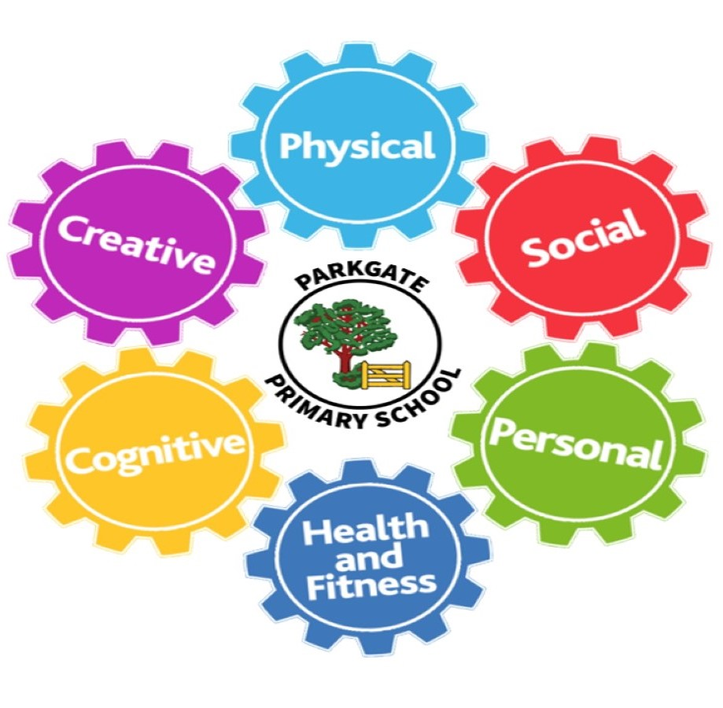

Personal  - self esteem  - identity  - confidence  - behaviour | Social  - communication  - working with others  - sharing ideas  - taking turns | Health and Fitness  - wellbeing  - healthy eating  - exercise  - looking after your body and mind
Creative  - taking risks  - problem solving  - trying something new  - asking challenging questions | Physical  - active learning  - choosing resources  - moving our bodies  - using our senses | Cognitive  - thinking  - remembering  - reasoning  - paying attention

REWARDS
The whole school reward system is designed around ‘University of Parkgate’ House System. This consists of collecting individual ‘House Points’ on a Bronze, Silver, Gold and Platinum level. There is also a whole school element through the allocation of each child to one of our ‘Houses’. The ‘Houses’ are named after what we consider to be key ‘drivers’ for our school and community.
UNIVERSITY OF PARKGATE
Our Houses are:

The House of Challenge
The House of Resilience
The House of Aspiration
The House of Pride

Children are rewarded HOUSE POINTS for the following:

- good work rate in class
- good effort
- positive attitude to learning
- achieving personal targets
- being able to self-regulate
- positive contributions in class
- up-holding the ‘Rights’
- making good progress
- home-learning
- out of school achievements
- citizenship
- meeting deadlines …………………………………………….to name just a few!

Rewards for the accumulation of House-Points over- time are varied and change regularly to reflect children’s wishes and ages. They can range from certificates, to wristbands and extra privileges like trips.

Extra special contributions are also recognised in the form of Headteacher’s Award. This can be awarded when appropriate and its value is appreciated by the children.

In addition the Headteacher or a member of SLT may from time to time send a postcard to a child’s home address or phone home as a reward for a positive behaviour/attitude. This is done without prior warning as a surprise.

CELEBRATION ASSEMBLY
Our Celebration Assembly also recognises
‘Marvellous Mathematician’
‘Star Writer’
‘Super Scientist’
‘Amazing Artist’
‘Remarkable Reader’ and other subject awards including ‘Home Learning’

A variety of personal rewards like stickers etc are given by class teachers.

Rewards are reviewed regularly and changed periodically when celebrating new initiatives or at the request of pupil voice.

PROCEDURES

At Parkgate we operate a Triangle System in classrooms.

When children do not uphold our 3 Rights, the following process is put in place after teacher are certain that the classroom environment is conducive to learning and that children feel safe.
Please see Appendix 1 for procedural flowchart.
- 1st Stage - a verbal warning/look
- 2nd Stage - the first side of a triangle is drawn on the board with the child’s initials
- 3rd Stage – the second side of the triangle is drawn on the board and a warning issued that if the behaviour persists and the triangle is closed they will be asked to leave the class and report to their ‘Time-Out’ Partner Class.
- 4th Stage –triangle closed and child leaves the room to ‘Time-Out’ for 15 minutes with a self-review sheet or learning to complete.
- 5th Stage –sent to a member of the Senior Leadership Team (an ADHT, DHT or Headteacher as appropriate)

‘Time-Out’ can result in the loss of a privilege e.g. Playtime. Parents will be informed if a child reaches 3 ‘Time-Outs’ over a half-term period.

Children progress down the stages of sanctions but at each stage they have the option to ‘turn their behaviour around’ and make the right choices.

Progress and Standards Leads are informed of all ‘Time-Outs’ in their Phase.
Non class-based members of our Senior Leadership Team support each Phase and they may be called upon to talk to classes, groups or individuals about behaviour at any time Progress and Standards Leads or Class Teachers deem appropriate.

If a child is a persistent offender and does not appear to be willing, or able to self-regulate, the Headteacher or Deputy may contact parents to work in partnership around issues to do with their child’s behaviour. This may be a course of action if the school is aware of issues for the child outside school which may affect behaviour e.g. family break-up, bereavement, domestic abuse, safeguarding concerns etc.

Both the rewards and sanctions are displayed in classrooms and public areas of the school.

In addition, the Headteacher or Deputy may become directly involved in a behaviour incident, especially if it is of a serious nature such as racism, homophobic language, bullying, peer on peer abuse or an assault on another member of the school community.

There may also be rare occasions where a child behaves in a way that seriously contravenes the school’s 3 Rights. In this situation it may be necessary to exclude a child for a fixed period. Details of the LA exclusion policy can be obtained from the school office. Please see list of possible reasons for exclusion on page 5.

Please refer to the Safer Handling Policy for further guidance on de-escalation techniques and the safe-handling of children.

Excellent behaviour is also expected at lunchtimes. The principles of this policy also apply at unstructured times when the children are supervised by DRAs. DRAs will reward good behaviour with stickers and a weekly DRA award in the Phase Assembly. If a child behaves in a way that is not appropriate then their behaviour will be recorded on ‘Lunchtime White Form’ by the DRA and handed to the class teacher. Persistent poor behaviour will lead to a child being placed in our ‘Restorative Room’ or in extreme cases parents may be asked to remove their child at lunchtimes. This would constitute a fixed term exclusion and be recorded as such through the formal process.

Any incidents of poor behaviour at playtime and lunchtime will be followed up by a senior member of staff where appropriate and recorded on CPOMS so that we can monitor them closely in order to adapt provision where necessary.

LUNCHTIME PROVISION

Lunchtime provision is in place for some of our more vulnerable children for whom lunchtime is complex. This is a positive intervention and takes into account the children’s interests. A range of clubs are on offer to support these children.

OVERCOMING BARRIERS TO LEARNING TEAM (OB2L)

At times a member of our ‘Overcoming Barriers to Learning’ may become involved with a child and their family. This team consists of Learning Mentors and a Family Support Workers that are trained to help children and families experiencing difficulties.

It is hoped that all parents/carers will support the school’s ‘Personal Development, Behaviour and Welfare Policy’ and reinforce the key message of respect with their child. The school works hard to work in partnership with parents. All children asked to sign a School Charter when they start each new academic.

CLINICAL PSYCHOLOGIST AND ANIMAL ASSISTED ACTIVITY

The School employs a Clinical Psychologist for two days a week to support children, staff and parents. Parkgate also has two Animal Assisted Activity dogs, Jed and Frankie.

This additionality supports Parkgate’s commitment to ensuring positive Mental Health.

THRIVE

Parkgate Primary is proud to be a Thrive School.

Based on neuroscience and attachment theory, the Thrive Approach offers a dynamic, developmental, trauma sensitive approach that helps teachers and adults interpret the behaviour and meet the emotional and social needs of children and young people.

This policy will be reviewed once each academic year.

This policy was reviewed in July 2019. This is a review of the policy devised in September 2015 with changes drawn to the attention of staff, parents, children and governors.

Zoe Richards
Headteacher

Reviewed by Full Governors – September 2019

Signed: Carol Blair (Chair of Governors) ………………………………

Date: To be reviewed Autumn 2020

Reasons for fixed term and permanent /exclusions

Physical assault  Includes:  Fighting  Violent behaviour  Wounding  Obstruction and jostling | Verbal abuse / threatening behaviour  Includes:  Threatened violence  Aggressive behaviour  Swearing  Verbal intimidation  Carrying an offensive weapon
Bullying
Includes:
Verbal bullying
Physical bullying
LGBT bullying
Racist bullying
Lesbian, Gay, Bisexual and Transgender abuse  Includes:  Taunting and harassment  Derogatory LGBT statements  Swearing that can be attributed to LGBT characteristics  LGBT bullying  LGBT graffiti | Racist abuse  Includes:  Taunting and harassment  Derogatory racist statements  Swearing that can be attributed to racist characteristics  Racist bullying  Racist graffiti
Sexual misconduct and Peer on Peer abuse  Includes:  Sexual abuse  Sexual assault  Sexual harassment  Lewd behaviour  Sexual bullying  Sexual graffiti | Drug and alcohol related  Includes:  Possession of illegal drugs  Inappropriate use of prescribed drugs  Drug dealing  Smoking  Alcohol abuse  Substance abuse
Damage  Includes:  Damage to school or personal property belonging to any member of the school community  Vandalism  Arson  Graffiti | Theft  Includes:  Stealing school property  Stealing personal property (pupil or adult)  Stealing from local shops on a school outing  Selling and dealing in stolen property
Persistent disruptive behaviour  Includes:  Challenging behaviour  Disobedience  Persistent violation of school rules | Other  Includes:  Incidents which are not covered by the categories above, but this category should be used sparingly

Appendix 1

Behaviour Support Plan – Procedural Flowchart
Quality first teaching evidenced
Class teacher led PSHE lessons
Behaviour Policy followed

Behaviour Support Plan drafted
Plan shared with pupil and signed
Planned shared with and signed by all key staff
Plan signed by parents
Review meeting held
Multiagency reports disseminated in preparation for behaviour support meeting

Restorative interview held with pupil
More than 3 lunchtime reflections
Attending:
Class teacher
Teaching Assistants
SENCO
Inclusion Lead
Phase
OB2L rep.

Behaviour Support Planning Meeting Agreement drafted
Review date set (within half a term or sooner if required)
Classroom and or playground observations take place
At least one fixed term exclusion
Support and self-regulation strategies identified
Key staff identified
Parents interviewed
Pupils do not respond to strategies identified
Evidence from CPOMS
Key documents:
Restorative interview notes
Parent views
Observation notes
Multiagency reports
Lunchtime Club timetables
Support plan proforma

Triggers
Learning needs identified
Meeting with CT and phase leader

