**

*‘Opening the Gate to Success’*

**Parkgate Primary School**

**Teaching and Learning, Curriculum Planning and Assessment Policy**

**Key Stage 1 & 2**

*September 2019 (to be reviewed July 2020)*

**Rationale**

This policy for assessment, planning, teaching and learning is the core policy of Parkgate Primary School. It informs effective practices and provision to enable all children to make good progress in every lesson taught to be the best they can be at that moment in time.

Assessment, planning, teaching and learning, set within an engaging and relevant curriculum, are a core entitlement for all children at Parkgate. The quality of teaching needs to be consistently good or better to ensure appropriate rates of progress for all learners and the accelerated progress of children identified as slow moving, stuck or falling behind. At Parkgate, we have the highest expectations and aspirations for where each child needs to leave Primary School equipped for the next stage in their education.

|  |  |
| --- | --- |
| **Our Aims** - what we want our school to be | **Our Values** - how we will act and behave |
| * Warm, Welcoming and Caring * Exciting and Inspiring * Part of the local community | * Professional and approachable * Be inspirational role models * Work effectively as a whole team * Be aware of the emotional wellbeing of myself and others |

|  |  |  |
| --- | --- | --- |
| We would like our  children to: | We would like our  parents and carers to: | We would like our governors and  teaching community to: |
| * Develop a love of learning! * Feel safe and happy and secure * Become independent learners and creative thinkers * Be resilient, ambitious and proud of their achievements * Creative thinkers and confident talkers * Be aware of their physical health and emotional well-being | * Support a love of learning! * Feel valued as partners of our school * Support their child's learning journey * Support the physical health and emotional well-being of themselves and their family | * Instil a love of learning! * Be committed to their profession and our children * Be approachable and positive * Work as a team * Be inspired and inspire others * Promote and support the well-being of ourselves and others |

**Positive Learning Behaviour – the 3 Rs**

In order for effective teaching and learning to take place there must be good standards of behaviour.

All learners at Parkgate have:

The **R**ight to learn (and teachers have the right to teach)

The **R**ight to be safe

The **R**ight to be respected

Classroom expectations and routines must be explicitly and consistently enforced and reinforced by all staff.

The 3Rs must be displayed in every classroom above the interactive screen and used in discussions with children around their behaviour.

This policy and guidance document should be read alongside other key policies and documents, particularly:

* Personal Development, Behaviour and Welfare Policy (including the class ‘Pupils Causing Concern’ file and CPOMs)
* Single Equality Plan
* Safeguarding and Child Protection Policy and Procedures
* Attendance Policy
* English and Mathematics Policies and Practices
* Early Years Foundation Stage Policy
* Inclusion Policy (including Pupil Premium, SEND/Achievement for All, More Able, EAL and vulnerable groups)
* Performance Management Policy
* PSHCE and SRE policy
* RE policy

**Teaching and Learning**

**The Park8**

The ‘Park8’ are the focus for Continuing Professional Development (CPD).

1. Organising Learning
2. Modelling
3. Differentiation
4. Critical Thinking
5. Oracy
6. Independent Learning
7. Collaborative Learning
8. Feedback

|  |  |  |
| --- | --- | --- |
| **Organising Learning**   * the journey through learning (a term/unit/lesson/guided session) * the creative use of learning intentions and toolkits/success criteria * the various structures of a lesson | **Modelling**   * concrete materials/resources * the journey of C.P.A. concrete – pictorial – abstract * adults as models for learning (learning behaviours, verbal, written, responses) | **Differentiation**   * appropriate support and challenge * flexibility of planning * increased variety of strategies * use of effective question types * use of scaffolds * use of groupings |
| **Critical Thinking**   * building resilience * problem solving * encouraging children to question and challenge * sustained shared thinking * integrating SMSC across the curriculum | **Park8**  **the use of rigorous AfL** | **Oracy**   * use the language of learning (modelled by adults) * confidence to discuss learning and next steps * effectively communicate in a variety of situations * supportive scaffolds |
| **Independent Learning**   * learning behaviours * climate for learning * providing a range of opportunities for home learning | **Collaborative Learning**   * articulating learning to others * roles and responsibilities * problem solving * recognising the contribution that a range of cultures make to the curriculum | **Feedback**   * deal with errors and misconceptions * offer challenge and support * inform future planning * move learning forward * apply/embed skills |

**Teaching and Learning Strategies used at Parkgate**

Learning Partners

* randomly chosen at the start of each week and are displayed in the classroom.

Named Lolly sticks

* response mode for open ended questions

Learning Intentions (LI) / Context (C)

* shared each lesson with the children to focus the learning and feedback, and to support articulation of their learning
* LI: To….
* C: (theme title, resources…)

Feedback

* Regular feedback is given as appropriate (written or verbal) based on Assessment for Learning, as close to learning as possible
* Marking codes are used to support written feedback (these are stuck inside Maths, English and Theme books)

Some AFL strategies

|  |  |  |  |
| --- | --- | --- | --- |
| starter / review tasks | question for discussion | relay | traffic lights |
| find the fib / mistake | silent debate | identify / talk about learning | ticket out the door |
| true / false & agree / disagree | chocolate box | peer / self-assess |  |

**Our Curriculum**

Our curriculum is underpinned by our Parkgate Learning Cogs which link together to drive Challenge, Resilience, Aspiration and Pride in our community.

|  |  |  |
| --- | --- | --- |
| **Personal**   * self esteem * identity * confidence * behaviour | **Social**   * communication * working with others * sharing ideas * taking turns | **Health and Fitness**   * wellbeing * healthy eating * exercise * looking after your body and mind |
| **Creative**   * taking risks * problem solving * trying something new * asking challenging questions | **Physical**   * active learning * choosing resources * moving our bodies * using our senses | **Cognitive**   * thinking * remembering * reasoning * paying attention |

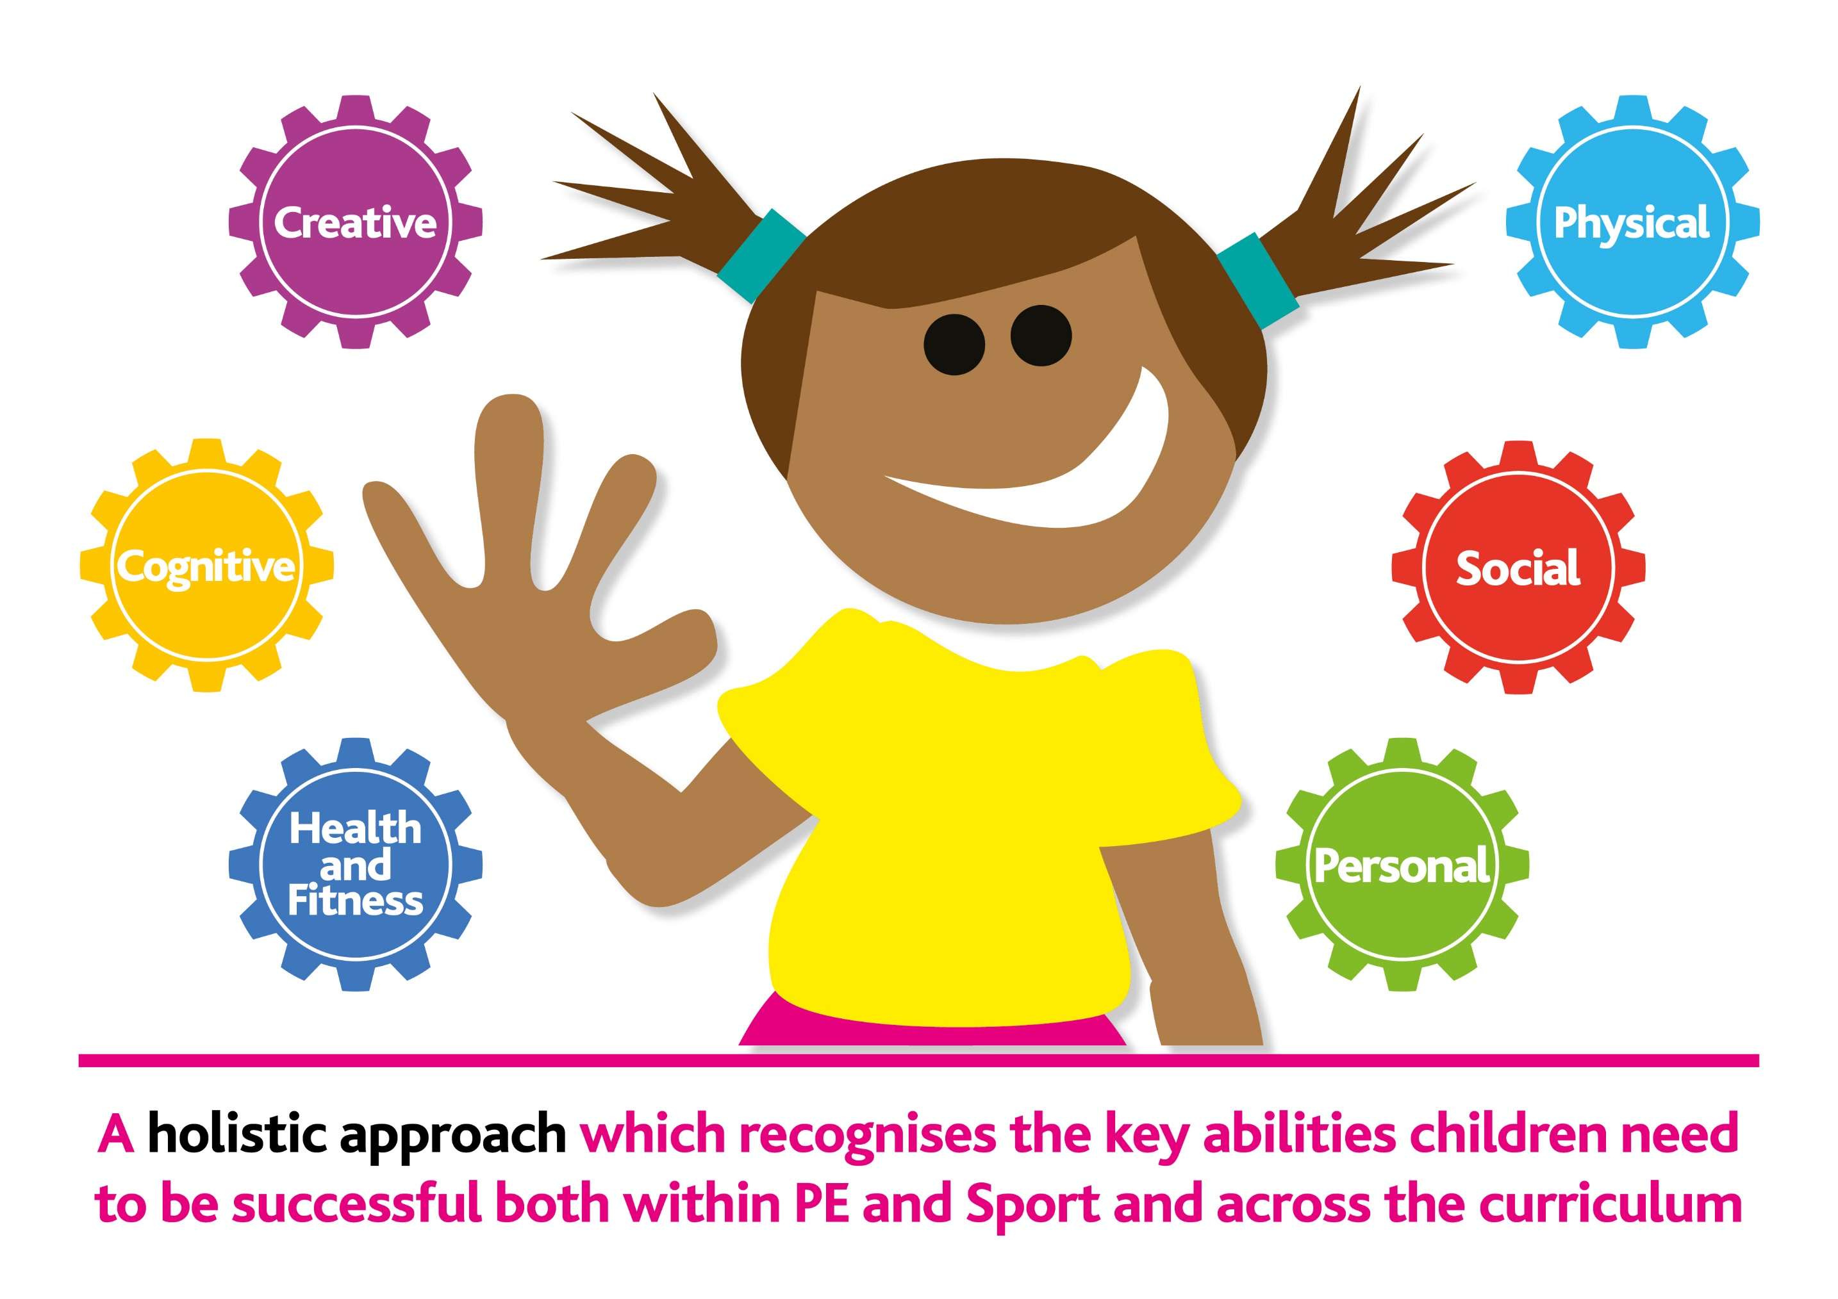

**about me**



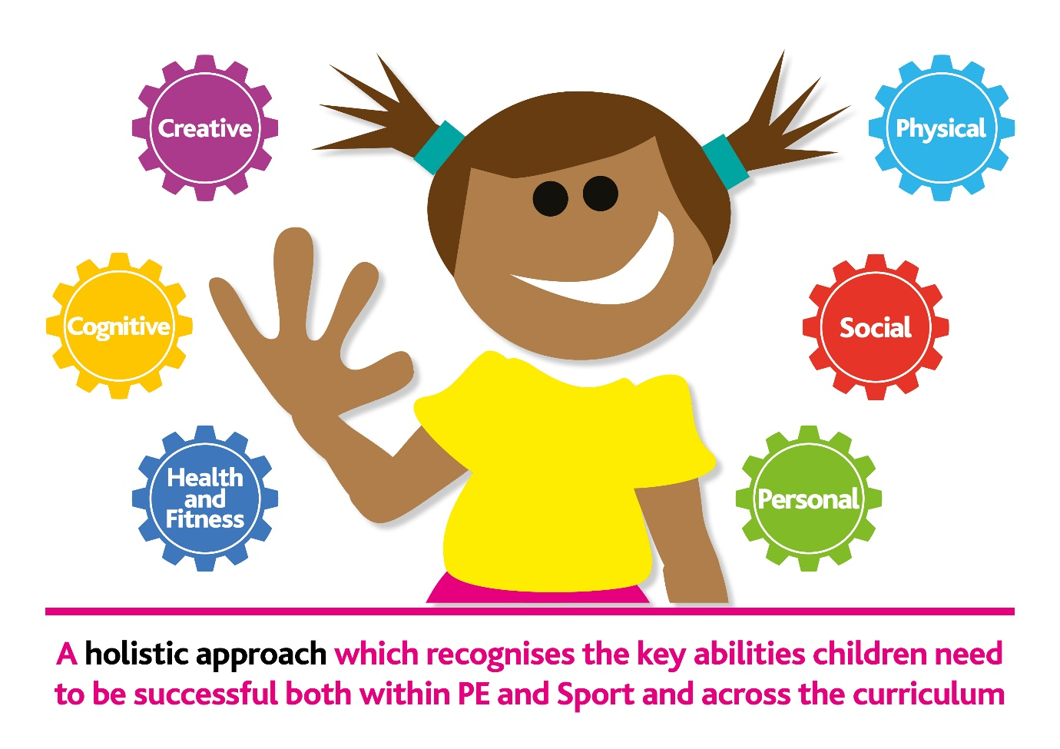

**fresh eyes**



**being active**



**brain skills**



**ready to learn**



**about us**

**Our Curriculum Vision**

**Inspirational:** an engaging theme to stimulate and motivate minds to learn

* will develop the children’s curiosity
* will capture the interest
* means making it relevant

**Responsive:** reacting to the world we live in, the community we are part of, the class we are in and the people we are

* respond to world and national events (current affairs, sport, culture, anniversaries), community and school events
* includes opportunities for responding to questions and interests of those within the class (individual, group)

**Flexible:** doing our own thing in our own way for our children

* will personalise the curriculum to be child centred and community driven
* allows you to organise your own curriculum for your class
* themes will be organised, based on how long the learning takes, across a day, number of days, weeks

**Experiential:** learning without boundaries

* includes a trip to enhance the learning, a visitor to give greater knowledge, using the wider school environment, working with the local community, using a range of technology and access to specialised resources

**Successful:** learning together to fulfil our potential

* developing knowledge across all curriculum subjects
* learning transferable skills across all curriculum subjects
* making progress

**Curriculum Themes in Years 1 to 6**, the National Curriculum subjects have been organised into themes and cross- curricular links are been made where appropriate (where themes do not include Science, it is taught in discrete weekly lessons)

**Timetables** for Years 1-6 have been established for each class to ensure appropriate time is allocated to a broad and balanced curriculum

At Parkgate, we make effective use of a variety of core resources and planning frameworks to support our long, medium and short term planning and assessment. These include:

* The National Curriculum
* Oxford Reading Tree Floppy Phonics, No Nonsense Spelling, PenPals for Handwriting, Accelerated Reader , Rapid Reading, BugClub
* PAL Maths, ABBC Maths, Timestables Rockstars
* School-based documents detailed in the ‘Story of…’ folders
* Parkgate Key Skills documents - foundation curriculum subject specific

At Parkgate, year teams meet regularly to plan and review the overview of learning for the year group. In addition, the year / phase teams regularly moderate teacher assessments and monitor standards, particularly in reading, writing and mathematics.

In shared P.P.A. we use our knowledge of the children, assessment data and informal assessments to plan personalised differentiated programmes of learning (short term planning) to meet the needs and interests of all children. Year groups first agree medium term planning and short term learning. Class teachers are then responsible for producing their own English and Maths short term plan which ensures good progress for all children through choice of activity, taking into account learning styles and class organisation.

Where the quality of teaching and/or progress of children are causing a concern, planning and on-going teacher assessment evidence will form part of the monitoring process.

Lesson planning and on-going informal assessment at Parkgate should be active and dynamic with class teachers adapting their planning, particularly if children have either grasped the learning more quickly than expected or misunderstandings or gaps in learning have been identified as part of the assessment and review practices within the lesson. Any misunderstandings, incorrect assumptions and/or gaps in children’s learning should be dealt with quickly and effectively so that children are able to re-construct their learning and ideas and make good rates of progress. Any potential obstacles to progress should be identified and addressed quickly by all staff to ensure good progress for all children. Practitioners and class teachers should constantly adapt their lessons, curriculum and use of interventions to meet the needs of all children in their class.

**Curriculum and Home Learning**

At Parkgate, our curriculum is designed to engage and excite all children. We plan appropriate activities within the theme to develop our children’s knowledge, skills and understanding in the core subjects and areas of learning/curriculum subjects being focused on each term. The curriculum themes should develop and evolve in each class to reflect the needs and interests of the current cohort of children.

Class teachers will provide parents and carers with a suggested range of engaging and accessible activities, linked to the current theme learning, that children can select from on ‘Termly year group planners’ and/or the on-line learning platform(s).

The deadlines for these activities are staggered throughout the year to ensure the momentum and motivation for learning is not lost and children can receive regular feedback. Feedback on home learning should be done verbally though in class sharing and celebration opportunities and in written form by the class teacher throughout the year. Once each term, Home Learning achievements are the focus of a celebration assembly.

Class teachers should monitor children’s engagement with home learning throughout the term and follow up individual children that are not engaging to establish what the possible barriers are and aim to address them in partnership with parents and carers.

Half termly maths targets and spellings are also sent home for children to practise key skills and reinforce classroom learning.

**Curriculum: Social, Moral, Spiritual and Cultural**

At Parkgate, we ensure we include relevant elements of Social, Moral, Spiritual and Cultural education as part of all our curriculum planning. In particular, trying to ensure there are opportunities planned for ‘awe and wonder’ as a regular feature of lessons.

Whole school curriculum areas such as Physical Education (PE) and Religious Education (RE) are allocated explicit time in the timetable. PSHCE is also a key component of family vertical groupings in Year 3 to Year 6. Family groups meet twice each half term on a Friday afternoon. Focused PSHCE lessons and circle time are also timetabled on Monday mornings for all classes in Year 1 to Year 6. As issues arise in individual classes or year groups, class teachers should address them directly using this time or other available time, such as Phase assemblies, when appropriate.

**The Learning Environment**

At Parkgate, the classroom environment supports learning and promotes positive behaviour. See Environment Checklist of non-negotiable expectations for classrooms and learning areas.

Class teachers maintain class and school displays to ensure they are fresh and relevant to children’s learning and celebrate achievement.

Staff ensure that designated areas are compliant with these expectations from the start of the academic year and throughout. SLT regularly monitor the learning environment and take whatever steps are necessary to ensure consistency across the school around the shared learning areas.

Each year group will provide a display of their most recent learning journey in the main corridor.

Autumn Term: Yr 4 and Yr 6 Spring Term: Yr 2 and Yr 5 Summer Term: Yr 1 and Yr 3

**Assessment**

The principles that underpin our assessment system are:

* Every child can achieve, teachers have the mind-set, ‘What do I need to do next to enable a child in my class to achieve?’
* The National Curriculum objectives will be used as the expectations for all children.
* Pupils will make age appropriate progress from their different starting points – 12 months in 12 months, more for those who need to 'close the gap' to reach age related expectations.
* Teachers are experts at assessment - assessment will be effectively used to ensure the correct scaffolding is built into lessons to ensure all children achieve.
* Assessment information will only be accurate and valuable if it is the result of rich and engaging learning opportunities. If children are bored and disengaged, they will not demonstrate what they know, understand and can do in their work.

Our assessment and reporting system includes:

* Robust ongoing assessment against the National Curriculum statements by the class teacher throughout each lesson, through questioning, observation and dialogue.
* The full use of a range of assessments to constantly identify children not making expected progress and, where appropriate, seek advice and guidance on possible next steps
* Children knowing what they are being asked to learn and more importantly, why.
* Three way feedback, child, peer, teacher with clearly identified learning points – this can be written or verbal feedback.
* Regular scrutiny of children’s work.
* Termly tests for reading, GPaS and maths.
* Termly pupil progress meetings between class teachers and SLT, as appropriate to need. These establish how the children are performing in relation to their age related expectations and to find ways to ensure that all children are supported / challenged in their learning in a manner that reflects their individual needs.
* Identified underachieving children should be targeted for additional intervention or support to ensure they make accelerated progress to catch up and keep up with their peers.
* SLT monitor the progress of identified underachieving groups each term to ensure that provision, planned interventions and teaching and learning strategies are having the intended impact and take appropriate actions where progress is not being made.
* School records and information passed from teacher to teacher
* Regular training / updates for staff in our approach to assessment and a senior leader who is responsible for assessment across the school.

We assess so that:

* Teachers can assess what children know, understand and can apply to their work.
* Teachers can plan learning opportunities that reflect the needs of all children.
* We can identify children who are falling behind and therefore plan support / intervention to address their needs.
* We can identify children exceeding their age related expectations and therefore plan work to deepen their understanding.
* We can provide parents with information about their child’s learning.
* We can provide useful data for analysis, whole school planning and accountability.

How we assess:

* **Formative** on-going assessment that involves teachers giving feedback to children that relates to what they have achieved and areas they need to improve on.
* **Summative** decisions are made about children’s achievement at the end of each term and annually. These decisions are based upon bodies of the children’s work but tests. We recognise that, whilst useful, summative tests only provide a snapshot of performance at any given time.
* Teachers input their moderated, summative assessments on oTrack towards the end of each term.

**Termly Assessments / Tests Yr 1 – 6**

|  |  |  |  |  |  |  |  |  |  |  |  |  |
| --- | --- | --- | --- | --- | --- | --- | --- | --- | --- | --- | --- | --- |
|  | Year 1 | | | Year 2 | | | Year 3, 4 & 5 | | | Year 6 | | |
|  | Aut | Spr | Sum | Aut | Spr | Sum | Aut | Spr | Sum | Aut | Spr | Sum |
| Maths | HeadStart (if approp.) | | | HeadStart (if approp.) | SATs | SATs | HeadStart | | QCA | HeadStart/SATs | | SATs |
| Reading | HeadStart (if approp.) | | | HeadStart (if approp.)/STAR | SATs | SATs | HeadStart | | QCA | HeadStart | | SATs |
| GaPS | N/A | | | Rising Stars | SATs | SATs | Rising Stars | | | Rising Stars | | SATs |
| Writing | Teacher Assessment | | | | | | | | | | | |
| Foundation subjects + science | Teacher Assessments based on Parkgate Foundation Subject Assessment Grids | | | | | | | | | | | |

* The use of Salford and York reading age tests and Sandwell maths tests for children identified for specific reading and maths interventions, as appropriate to the timing of the intervention, to measure impact and identify next steps.
* The use of Welcomm and Speech-link to identify children who require further language support.
* Foundation subject’s assessments are recorded on the Parkgate Curriculum Theme Records. At the end of each term/theme data is recorded on OTrack.

**Statutory Assessments (End of Key Stage)**

Children complete the following statutory assessments:

* Reception – EYFS profile
* Year 1 (and 2) - Phonics Screening Check
* Year 4 Multiplication Tables Check
* Years 2 and 6 - end of Key Stage assessments (reading, writing, and maths) (GPaS in 6 only)

**Moderation**

* Assessment judgements are moderated termly between classes, across school and our network to make sure our assessments are fair, reliable and valid.

Moderation evidence:

* A child is not required to demonstrate a statement on a specific number of occasions for them to be assessed as having achieved it. However, they should be able to demonstrate and apply the skill or knowledge independently, where appropriate in a different subject or context. Problems and texts should be appropriate to the standard being judged.
* Tests will be used to inform judgements.

**School Codes**

We use the following codes to assess children’s’ knowledge of the curriculum, against age-related expectations, in each core subject area:

* Beginning (B),
* Developing (D),
* Secure (S)

|  |  |  |  |  |  |  |  |  |  |  |  |  |  |  |  |  |  |  |
| --- | --- | --- | --- | --- | --- | --- | --- | --- | --- | --- | --- | --- | --- | --- | --- | --- | --- | --- |
|  | Year 1 | | | Year 2 | | | Year 3 | | | Year 4 | | | Year 5 | | | Year 6 | | |
| Term | Au | Sp | Su | Au | Sp | Su | Au | Sp | Su | Au | Sp | Su | Au | Sp | Su | Au | Sp | Su |
| Expectation | B1 | D1 | S1 | B2 | D2 | S2 | B3 | D3 | S3 | B4 | D4 | S4 | B5 | D5 | S5 | B6 | D6 | S6 |

* A child that has achieved vast majority / all the objectives set out for Year 3 for reading (and no further) is said to be working at the end of Year 3 expectation for reading (S3)
* A child will deepen their understanding within age-related expectations rather than starting content from the next year. The children working with greater depth will be indicated by a ‘+’

**Tracking progress over-time, Yr 1 – 6**

To effectively track progress overtime our school codes are linked to progress points, these are used to examine progress and attainment numerically (as an average).

|  |  |  |  |  |  |  |  |  |  |  |  |  |  |  |  |  |  |  |
| --- | --- | --- | --- | --- | --- | --- | --- | --- | --- | --- | --- | --- | --- | --- | --- | --- | --- | --- |
|  | Year 1 | | | Year 2 | | | Year 3 | | | Year 4 | | | Year 5 | | | Year 6 | | |
| Term | Au | Sp | Su | Au | Sp | Su | Au | Sp | Su | Au | Sp | Su | Au | Sp | Su | Au | Sp | Su |
| Expectation | B1 | D1 | S1 | B2 | D2 | S2 | B3 | D3 | S3 | B4 | D4 | S4 | B5 | D5 | S5 | B6 | D6 | S6 |

* Children working with greater depth are awarded an additional termly point, e.g. S3+ = 11 + 1 = 12 points

**Distribution grids**

|  |  |
| --- | --- |
| The reading, writing and maths grids, updated termly, will support planning to address gaps in learning.  They will allow staff to see:   * where children / groups of children are in their learning; * whether children / groups of children are on track; * whether children / groups of children are meeting their potential; * how much progress is being made over time by the class; * the attainment at the end of the previous Key Stage. |  |

**Reporting to Parents/Carers**

Practitioners and class teachers should forge positive relationships with parents and carers and keep them fully informed of their child’s progress throughout the year. Any concerns regarding a child’s academic progress or behaviour should trigger a discussion with parents and carers either by telephone or a meeting arranged. This is in addition to any formal meetings that are called regarding any children currently on the Special Educational Needs or Disabilities (SEND) register or children or families requiring specific additional support from outside agencies where practitioners or class teachers may be required to attend or contribute relevant reports.

Formal reporting and parent and carer consultation meetings at Parkgate Primary School are as follows:

* ‘Meet the Teacher’ presentation by the class teacher at the beginning of the academic year to share the expectations around behaviour, attendance, curriculum and home learning.
* Parent/carer and child consultation meeting at the end of the Autumn term to give an opportunity for parents and carers to view their child’s learning. It is also an opportunity to share expectations and challenges, including information on home learning activities.
* Termly report cards report on the child’s attendance, attitude to learning, progress, attainment and feedback on home learning.
* Annual written report, at the end of the Spring term, includes comments on progress and attainment in all curriculum areas and next steps for the summer term.
* Termly ‘book look’ provides parents with an opportunity to celebrate children’s achievements.

**The Role of the Governors**

Governors have a crucial role in ensuring the school has accurate assessment information for all children. It is essential that governors are aware of how groups of children are performing and the progress they are making. The school will report to the governors termly on progress made in each year group and for each identifiable group of children.

**Progress and Standards Lead Role**

In their teams, Progress and Standards Leads are accountable for:

* regularly monitoring the quality of teaching and learning
* ensuring effective assessment practices are carried out, including effective feedback and reporting
* ensuring colleagues are planning for progress

Progress and Standards Leads should:

* Provide a good model of effective assessment, teaching and learning practices for their team.
* Support and challenge colleagues in their phase team to:
  + embed effective use of data and assessment for learning practices into their teaching and planning
  + embed effective feedback
  + ensure they are planning for progress using the appropriate core documents
* Ensure there is a discussion on improving an aspect of teaching and learning at each team meeting, based on whole school focuses and/or outcomes from monitoring.
* Regularly review aspects of curriculum planning across their team to ensure children’s entitlement to a broad and rich curriculum to meet their individual needs and interests.
* Ensure colleagues are personalising curriculum planning to meet the specific needs and interests of children in their class, including the appropriate differentiation of tasks across all subjects and the effective use of additional adults to accelerate progress.
* Evaluate the quality of feedback and marking, checking it is done regularly and consistently across the year group based on the whole school feedback and marking policy and marking codes.
* Ensure regular focused moderation of books and teacher assessments in phase meetings
* Review all relevant data for the year group to identify strengths and areas for development
* Carry out informal or support formal whole school monitoring activities
* Feedback outcomes from formal and informal monitoring at regular SLT meetings and Governing Body.
* Inform SLT where there are concerns about the quality of assessment, teaching and learning, linked progress of children are causing a concern.

**Faculty Lead Role**

(English, Maths, Curriculum and Assessment)

Faculty Leads, along with their Faculty Team, are accountable for developing, monitoring and evaluating the quality of all relevant aspects of assessment, curriculum planning, teaching and learning for their subject(s).

Faculty Leads should:

* Create and share a focused faculty action plan to improve key development areas in assessment, curriculum planning and/or teaching and learning – linking to the whole school Monitoring and Evaluation Calendar.
* Monitor and evaluate the focused faculty action plan each term and adapt plan as appropriate throughout the year.
* Analysis of relevant data to find strengths and weaknesses.
* Use of focused monitoring e.g. learning walks, book/planning scrutiny, pupil/staff voice.
* Keep up to date with national and local curriculum developments and disseminate relevant information and guidance to all staff.
* Provide guidance and support on assessment, curriculum planning, teaching and learning of their subject(s).
* Provide well-timed, focused support where necessary to ensure there is good quality provision across the whole school as soon as possible.
* Provide SLT and governing body with a summary report of monitoring outcomes, including impact of actions, value for money, identification of strengths and areas for future development as requested.
* Ensure value for money for allocated budget(s).

**Subject Leaders Role**

* Share key actions and priorities with Curriculum Lead
* Keep up to date with national and local curriculum developments and disseminate relevant information and guidance to all staff.
* Use of focused monitoring e.g. learning walks, book/planning scrutiny, pupil/staff voice.
* Provide guidance and support on curriculum planning, teaching and learning of their subject(s).
* Ensure value for money for allocated budget(s).