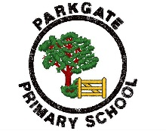

‘Opening the Gate to Success’

Dear Parents and Carers,

European Day of Languages 2022

On Monday 26th September all children in Years 1 up to 6 will be celebrating European Languages Day. Each year group will be finding out more about a country in Europe. Children can come to school in the colours of flag for their country if they wish:

Year 1 will be learning about England. Children can wear red and white clothes.

Year 2 will be learning about France. Children can wear red, white and blue clothes.

Year 3 will be learning about Spain. Children can wear red and yellow clothes.

Year 4 will be learning about Italy. Children can wear red, green and white clothes.

Year 5 will be learning about Poland. Children can wear red and white clothes.

Year 6 will be learning about Germany. Children can wear red, black and yellow clothes.

During the day children will have different learning opportunities which may include developing geography skills, learning words in a different language, music, dance and art.
We are looking forward to a fun filled day!

Thank you for your support,

Zoe Richards
Headteacher

