

**Does any of the information surprise you?**

**Is there anything else you would like to find out?**

Resource 1

*Look at the resource below, which shares some information about Mount Everest.*

Mount Everest is in southern Asia. It is located in the Himalayan mountain range between Nepal and Tibet (China).

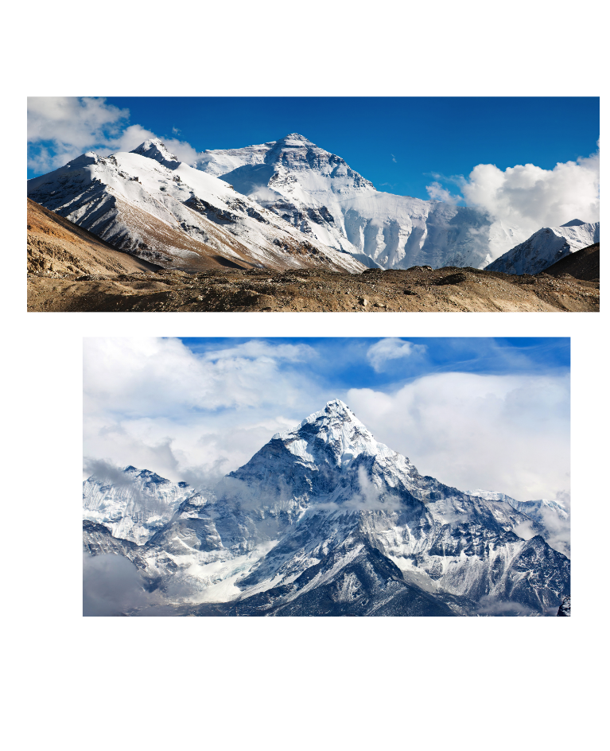

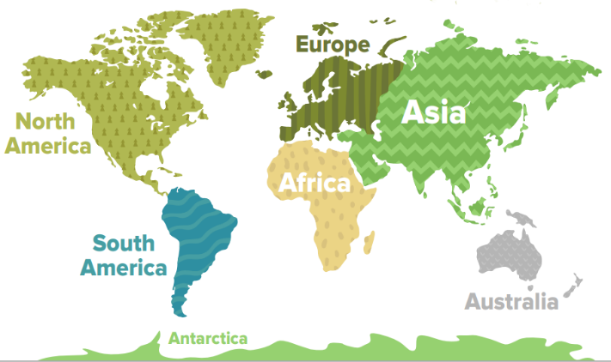

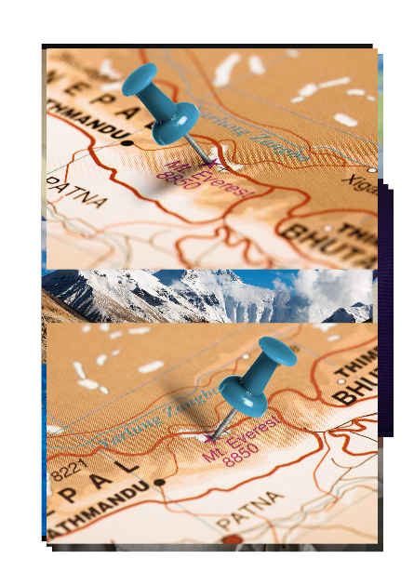

**Did you know?**

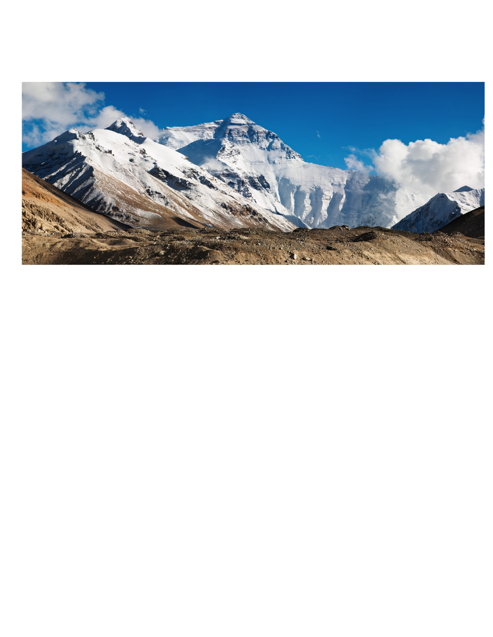

* Mount Everest is about 8848 metres (29028 feet) high.
* It was named in 1865 after British surveyor and geographer, Sir George Everest.
* On average, it takes 2 months to climb Mount Everest.
* The top of Mount Everest was first reached in 1953.
* The average temperature is -37⁰C.