*Look at the resource below, sharing information about four people who have climbed some of the world’s largest mountains.*

Resource 2

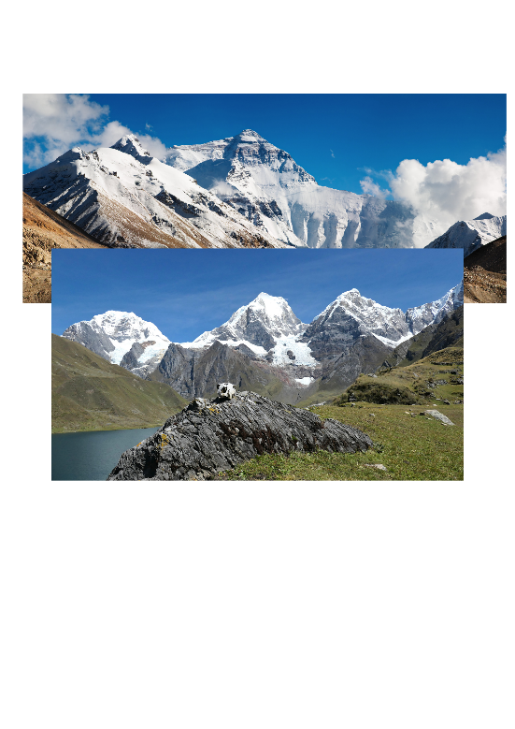 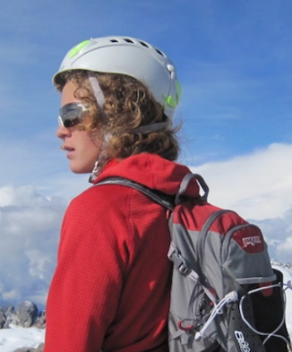

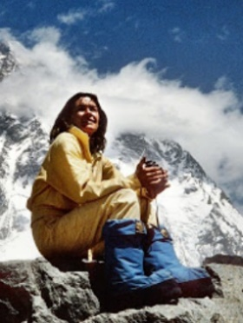

*Source: @PolishHistory Twitter page*

Wanda Rutkiewicz

Wanda Rutkiewicz was a polish mountain climber, who became the first woman to reach the summit of K2 in 1986. She was also the third female to reach the summit of

Everest in 1978. Sadly, she died in 1992, attempting to climb Kangchenjunga.

*Source: @SportKidsWear1 Twitter page*

*Siula Grande, Peruvian Andes*

**What skills do you think they would need to succeed?**

Jordan Romero

Jordan Romero currently holds the title for the youngest person to reach the summit of Mount Everest. The American was 13 years and 10 months old when he made it to the top on 22nd May 2010.

Joe Simpson is a British mountaineer. In 1985, he climbed Siula Grande, via the hitherto unclimbed west face. On the decent, he fell through a crevice and suffered severe injuries. He was thought to be lost but he managed to crawl back down.

Arunima Sinha from India conquered Mount Everest, the highest mountain in the world above sea level, on 21st May 2013. She did so with a prosthetic leg after her left leg was amputated two years earlier.

Joe Simpson

Arunima Sinha

*Source: summonedbyfells*

*Source: Dr. Arunima Sinha Twitter page*