Monday 21st September
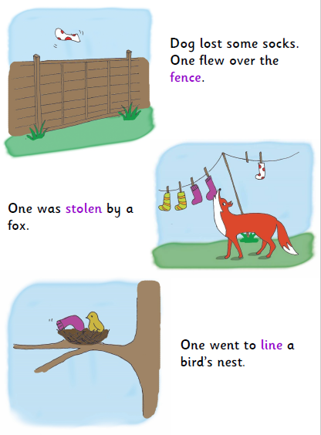
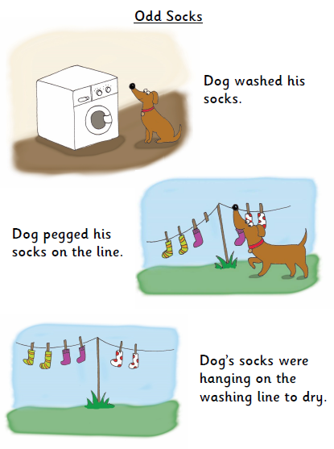
Please read this story with your child and discuss the questions on the following page.

- 2

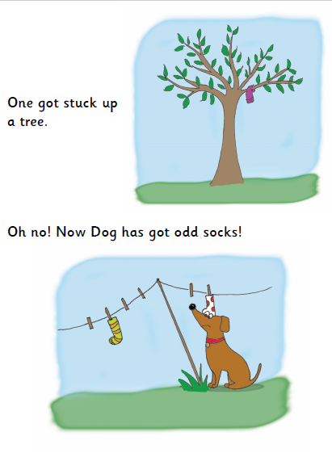
Discuss these questions with your child.

What did Dog do at the beginning of the story?

What did the fox do with one of Dog’s socks?

How do you think one got over the fence?

What did a bird do with one of the socks?

Do you think that Dog will find all of his socks? Why?

Name three other places you would think about looking for Dog’s socks.

3

