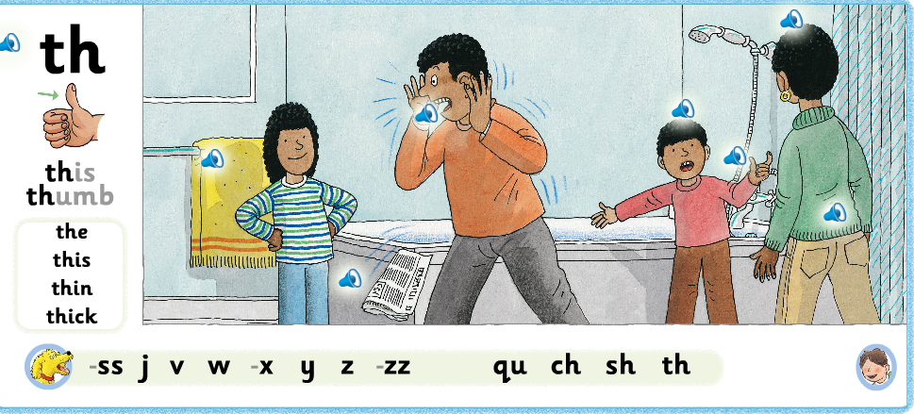
- Look at the page together. Talk about what is happening in the picture. Which characters can they see? What are they? Encourage your child to speak in sentences. Spot the things in the picture with the sound /th/ in them. ( bathtowel, bath, teeth, brother, mother, clothes) Can your child say where the sound is in each word, the beginning, the middle or the end.
- Say the sound together. Say “th as in this thumb” encourage your child to say the sound. Talk about th being a digraph, two letters that make one sound. It also makes either a soft or a harder sound depending on which word it is in. https://www.youtube.com/watch?v=ziEHM3IPVY4
- Blend to read section. Look at the words in the box, the, this, thin, thick. Encourage your child to say the individual sounds and then blend the sounds to make a word.

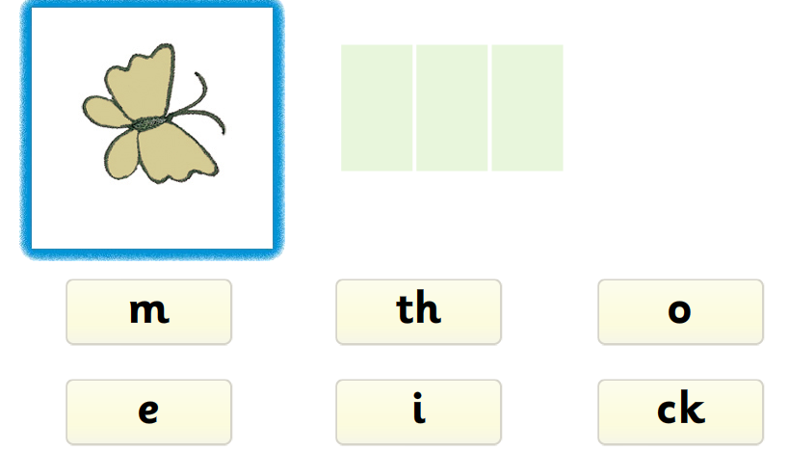

Segmenting to spell.
- Look at the individual picture. Encourage your child to say the word to describe the picture. Talk about how many sounds are in the words. This can be different to how many letters.
- Using their sounding out hands encourage your child to segment the word into the sounds within it.
- Together choose the correct sounds to make the words.
- You may also like to encourage your child to write the words on paper. They could try and write a simple sentence using the common irregular words such as, The moth is a bug.

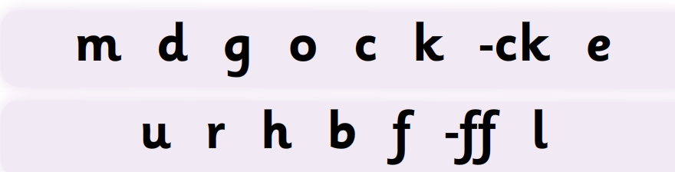

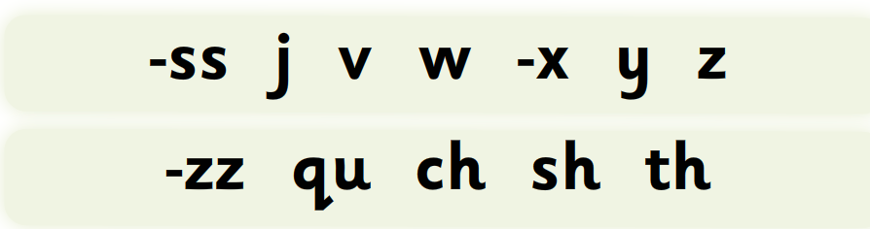

Practise saying these letter sounds together.

