Wednesday 23rd September

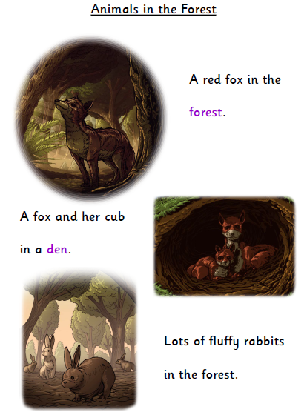Please read this text with your child and discuss the questions on the following page.

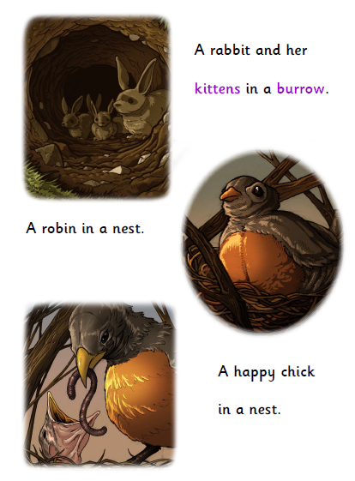

1

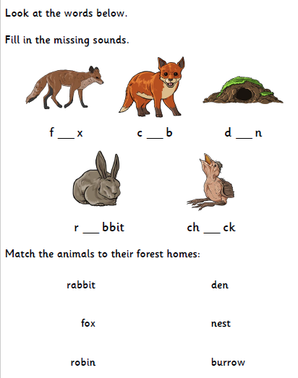

Discuss these questions with your child.

Where is the robin and her chick?

What is a burrow?

What is a baby fox called?

Is the chick happy or sad? Why?

In the story, the rabbit is fluffy and the chick is happy. Can you think of any different words to describe the animals?