Monday 20th September

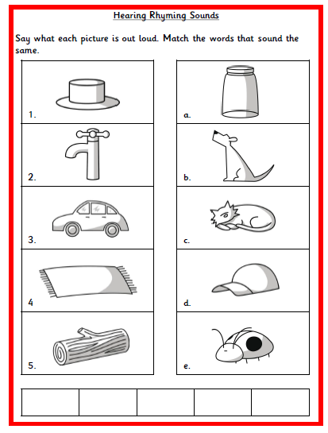
Can your child identify any other words that rhyme with the words?

